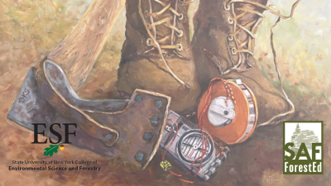
Accessing Practical Ethics
Required Reading Resource for the Practical Ethics Microcourse Series on ForestEd

Access Practical Ethics: A Field Guide for Resource Managers, by Marianne Patinelli-Dubay, Kendall Hunt Publishing, 2023.
Purchase the book HERE: https://he.kendallhunt.com/product/practical-ethics-field-guide-resource-managers!
You can select a hard copy or digital e-book format. Plan for shipping and delivery time should you select the hard copy format.

Digital e-book access instructions
There are two (2) e-book platform options. Instructions will outline access via the RedShelf platform as an example. However, you are not required to select RedShelf.
STEP 1: Go to Practical Ethics at Kendall Hunt Publishing Company and create an account. The account is required for your book purchase.
STEP 2: Purchase book – select your preferred e-book platform – for immediate access.
- PLEASE NOTE: The digital e-book has a limited period of access - 180 days - and your unique access.
STEP 3: Check your email from Higher Education (hetech@kendallhunt.com) for your eContent Access Information. Note your unique access code and instructions to access the book.
STEP 4: Follow eContent Access instructions for the selected platform. The following steps will be unique to RedShelf.
STEP 5: Go to http://www.redshelf.com
STEP 6: Click Login on the top right corner and Create a new account. Be sure to confirm your RedShelf Account registration sent to your email.
STEP 7: Select My Shelf and Redeem your access code provided in the Higher Education email referenced in STEP 3.
STEP 8: View your e-book copy of Practical Ethics within My Shelf and Start your reading!
If you need assistance with your code, please email HETech@kendallhunt.com with your name, email address, code and the issue you are having.

